List of Conference Partners who will be exhibiting at the Munster Voice Conference


John Keane Electrical Ltd represent Abacus Sportslighting, and is one of Irelands leading Sportslighting Specialists having successfully installed floodlighting systems throughout Ireland. We appreciate floodlighting a sports ground is a significant investment for any club, therefore, we support the club with a dedicated project management team. Experienced, qualified design engineers will design a lighting system that meets with your exact requirements. We install Abacus’ market leading base hinged raising and lowering mast designed for safe, hassle free, low cost maintenance, avoiding the need for heavy cherry pickers on the pitch for servicing. The Abacus Challenger 1® floodlight provides the idea solution for satisfying planning requirements associated with controlling light pollution. A flat glass design ensures zero upward light, whilst its 60° double asymmetric beam distribution ensures minimal glare and excellent containment of overspill. The Challenger ® also has the highest possible IP rating of any sports floodlight, at IP66. Contact John Keane John Keane Electrical Ltd
Tel 066 7141508 Mobile 0872534200 Email johnkeane@sportslighting.ie Web www.sportslighting.ie



Lairdesign specialises in graphic design and web solutions for the GAA. Our client list includes Ulster GAA, Munster GAA, National GAA, Tyrone Co Board and Club Tyrone as well as Cumann na mBunscol. We also work with numerous GAA clubs and colleges, designing their club badges, promotional material, websites and apparel. We have over 15 years’ experience working with the GAA, and our team are involved in gaelic games in coaching, playing or administrating in our own clubs. That means we know what we’re talking about because we know the GAA inside out. Squareball is Ireland’s first GAA fashion brand. Coolly iconoclastic, passionate, fun - Squareball gear puts the Attitude of the GAA in how you look. It’s what you want to be seen wearing. Playing is only Part of Lairdesign,| Lancer Building | Great Northern Rd | Omagh | BT78 5EJ Tel: 028 8225 2495 Email: collette@lairdesign.com


Goalpost Ireland has established itself as the leading Irish Professional Designer & Manufacturer for Goalposts and Sports Pitch Equipment to all the leading sporting bodies and associations. Manufacturers and suppliers of sports pitch equipment for GAA, Soccer, Rugby, Hockey, Dugouts, Pitch Accessories, Tennis, Basketball and much more. We also offer the services of our Specialist Installation Team who will install your goalposts to the appropriate Professional Specification. Goalpost Ireland has fitted the sports pitch equipment of: Croke Park, Lansdowne Rd, FAI, Semple Stadium, Páirc Ui Chaoimh, Gaelic Grounds, Fitzgerald Stadium, UCD, DCU and many more premier stadiums and clubs in Ireland. Goalpost Ireland’s Products are designed, manufactured and tested & to current International Safety Standard Requirements IS 356:2007, EN 748, EN 749, EN 750, BS 8462:2005. Complying with these standards is our guarantee to superior products. Contact Goalpost Ireland at: Goalpost Ireland, Tallow, Co. Waterford, Ireland. Tel: 058 56326 Fax: 058 56633 Email: sales@goalpostireland.com Web: www.goalpostireland.com


Rubber Pitches Ireland (RPI) upgrade, manage and maintain turf sports pitches throughout Ireland. From their base in Munster, RPI use innovative processes to improve the consistency and playability of pitches. They work closely with Crumb Rubber, who supply guaranteed Irish products, to improve the performance of turf pitches. RPI offer a full range of pitch maintenance services to provide ongoing consistent management. They also offer remedial treatments for problem areas such water logging, compaction, and low grass cover levels. RPI have an extensive fleet of their own machinery to provide a full range of Pitch Care services which include: Hollow core, Verti Drain, Scarify, Fertilise, Mow, Pitch Dressing, Improving problem areas, Goal Mouth upgrades. Contact: Conor O Neill: Phone: 087 935 8564 Email: conor@rpi.ie Web: www.rpi.ie
Laydex ltd; is the exclusive supplier and installer of the Fieldturf Tarkett range of Synthetic Sports surfaces suitable for most outdoor and indoor sports activities. The XT65 System has recently been tested to comply with the G A A standards and offers an exceptionally comfortable, safe and long lasting playing surface for both Football and Hurling. The system comprises of a Schmidt Foam Shock Pad underneath synthetic carpet ballasted with fine sand and filled with rubber particles. This gives excellent ball bounce and shock absorbency and plays as though it were a natural grass surface. Laydex has completed many projects Nationwide and the Louth Centre of Excellence at Darver is a fine example of the quality of the installation of the XT System.
Contact Details; Laydex Ltd, Allied Industrial Estate, Kylemore Rd, Dublin . Tel 016426600 Contact; Mr Gerry Callan, Sales Director 086 2596690

FSL Electronics are the leading company in Ireland for the design and manufacture of electronic GAA scoreboards. Working closely with clubs and county boards over the past 20 years FSL have designed, manufactured and installed more than 1200 scoreboards in every county in Ireland ranging from a 6 digit scoreboard for goals and points to full LED models showing team names, scores, time, advertising, general messages and substitutions during a game. Some notable installations include Croke Park, Parnell Park, Parc Ui Chaoimh, Wexford Park, Pearse Stadium, Casement Park, Celtic Park, Brewster Park, Semple Stadium, Athletic Grounds, Dr Cullen Park and soon to be installed in McHale Park. FSL offer everything from site survey, framework design, installation, commissioning and operator training, this commitment to customer needs have enabled FSL to maintain its position as the number one supplier for scoreboards and hopefully ensure that in the future every club will “know the score” with FSL. Sales Manager Paul O’Hara Phone 00442886766131(OFFICE), 07872649921(MOBILE) paulo@fslelectronics.com www.fslelectronics.com

Avenir Sports is a 100% Irish owned company and is the the master distributor of SportsCode, the worlds foremost video based performance analysis system and the choice of over 4000 leading teams and organisations worldwide. In 2009 alone Avenir Sports have worked closely with some of the countries top teams including All Ireland Senior Football Champions Kerry, Munster Hurling Champions Tipperary, Harty Cup champions Thurles C.B.S. and All Ireland Hurling Club Champions Portumna. Avenir’s SportsCode analysis software can be used to improve your coaches and players in every area from your under-age teams right through to the clubs most senior team. From coach education, to strenght and conditioning in the gym and on the field, to training ground analysis and on to the match day analysis of your own performance and that of your opponents Sportscode can help you and your club to reach your potential. Contact details :Tommy Conneely, Phone : 091 768486,
Mobile : 086 8555722, Email : info@avenirsports.ie Web : www.avenirsports.ie

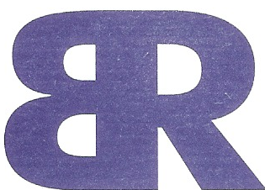
BR SPORTS FLOODLIGHTING is a CORK based Company set up by Bob Ryan to provide a complete turnkey floodlighting installation service for sports clubs throughout Munster with the Product and Design support of Philips Lighting Ireland Ltd. Bob Ryan has operated a successful Electrical Contracting business for 25 years and has vast experience in all facets of electrical installation work. I have also been involved in sport all my life and in sports administration at a high level over the last 10 years. I have a deep knowledge of what is required by Sports Clubs with regard to floodlighting systems. Having observed what has been offered to Sports Clubs in the past and the extremely inflated costs of same. I am confident that my experience and knowledge of electrical installation work and with the support of Philips Lighting Ireland Ltd I can provide a top class service at a very competitive price. All Light fittings and lamps used on our floodlighting systems are from the extensive range of Philips products and are fully guaranteed by Philips Lighting Ireland Ltd. Contact Loughane West, Vicarstown, Co Cork,Mobile 087-2584651, Tel, 021-4381147,E-mail: bobryanelec@gmail.com www.brsportslighting.com

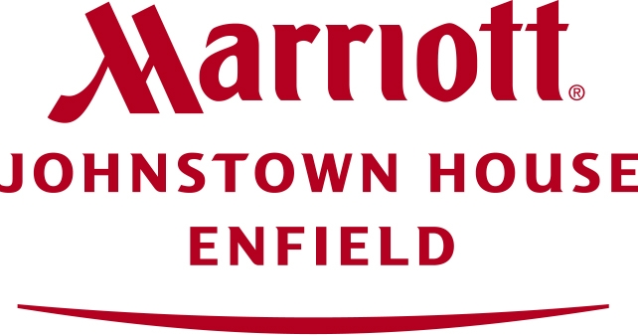
Marriott Johnstown House Hotel & Spa has recently developed on its extensive grounds a purpose built training facility (including its own all weather professional surface training grounds), providing the ideal location for team training Camps. Located just 35 minutes from Dublin on the M4 motorway, the facility has been used by many Senior County Teams including Galway Senior Hurlers & Football panels, Kildare Senior Football panel, Mayo Senior Football Panel and Cork Senior Football panel during the recent Championship season, as well as many Club sides. We cater for all budgets, and specialize in providing a one stop shop solution for your training camp requirements. The facility is also being used by both the FAI and IRFU for the various national squad training camps, and emerging talent programs. Contact details: David Hennessy 087 6396601 David.hennessy@blackshoreholdings.com www.marriottjohnstownhouse.com

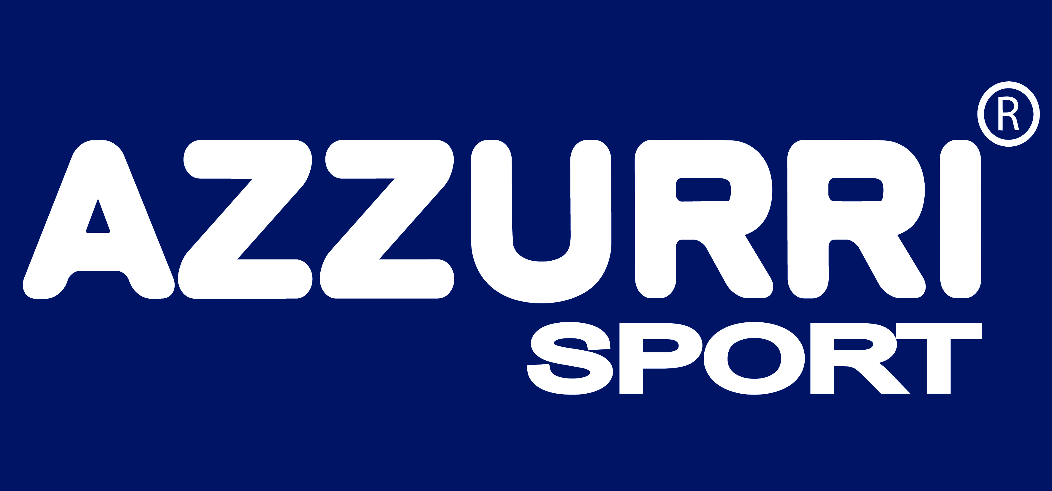
Azzurri Is an Irish owned and managed family business designing, manufacturing and supplying high quality performance sportswear. Azzurri supply GAA Jerseys, Rugby Jerseys, Soccer Jerseys, Athletics Jerseys, Basketball Jerseys to National and International Universities, Colleges, Clubs, Schools, Organisations. Contact Azzurri Sales on 051 850066 email sales@azzurri.ie www.azzurri.ie

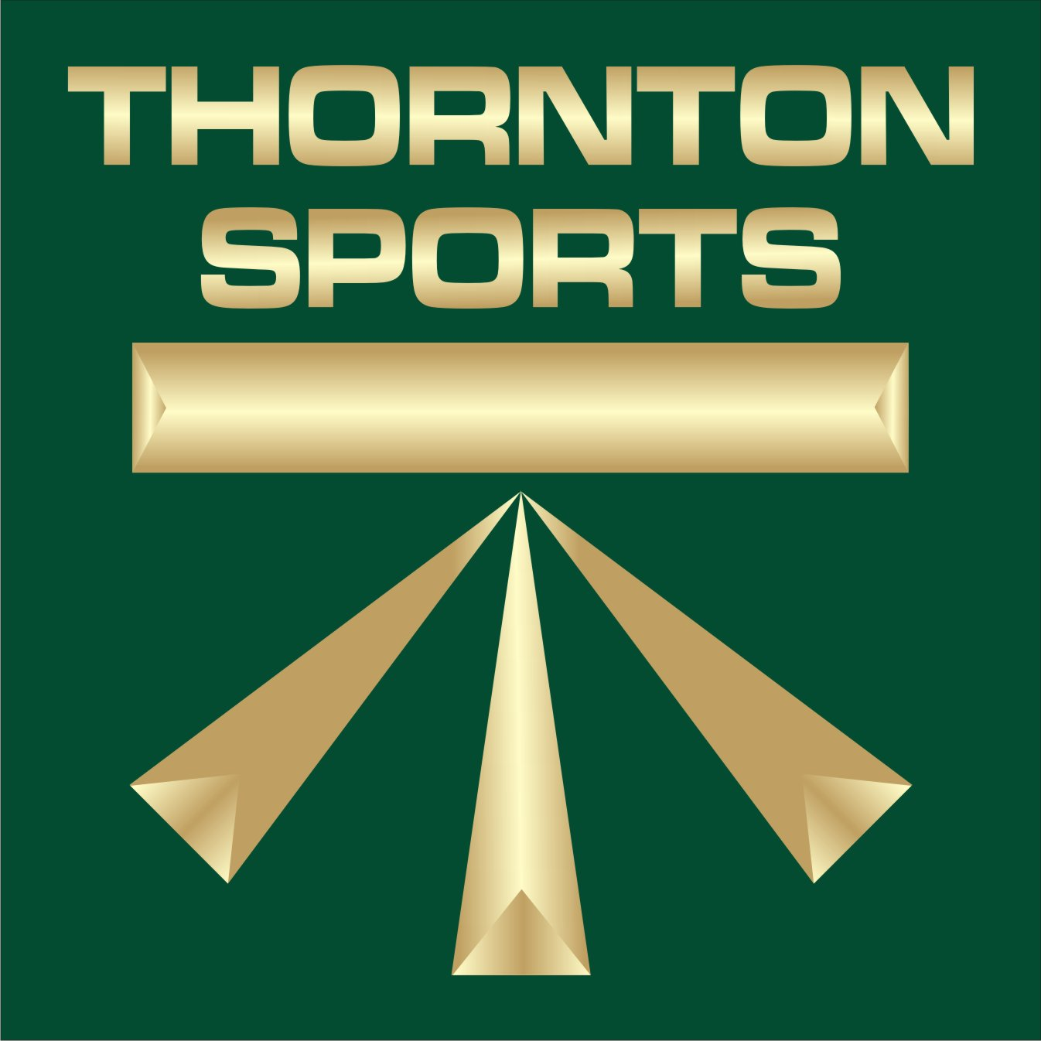
Thornton Sports have been building Synthetic Sports pitches for over twenty five years, for the last twelve operating from our base in Portumna Co Galway, during that same period we have laid over 400,000m2 of synthetic grass. We are delighted to announce that we have passed full laboratory testing for our synthetic grass which exceed the GAA’s new code of compliance, the first GAA synthetic pitch to meet the new code will be constructed by Thornton Sports for Dublin City council in Alphie Byrne Park, Clontarf. Open November 2009. Some of our previous clients include, Ahascragh GAA Galway, Ferry Bank GAA Waterford, St Vincent’s GAA Cork, Rathmore CLG Kerry, Longwood CLG Meath, Scarriff GAA Clare, NUI Maynooth Kildare , Laragh United CLG Cavan, St Rynaghs Offaly. Should your club be considering a synthetic training area please feel free to contact us for a free quotation, site survey and consultation. Contact Details Dick Ridge - Marketing and Development Manager 090 9741955 dick@gts.ie, www.thorntonsports.ie

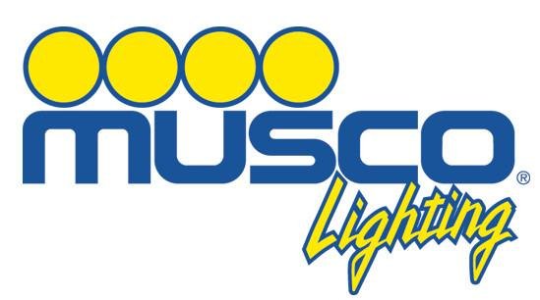
For over 30 years, Musco Sports Lighting has specialized in the design and manufacture of athletic pitch floodlighting. Musco has pioneered dramatic improvements in energy efficiency and affordable ways to control spill light and glare. Musco Lighting’s newest innovation, Light-Structure Green™, is the same complete foundation-to-poletop lighting system we have provided for years, but provides significant advantages for your budget and the environment. Operating costs are cut by up to half when compared to conventional lighting systems. Maintenance costs are eliminated for 10 years. Off-site spill lighting and glare are reduced by 50% and constant light levels are guaranteed for 10 years/5,000 hours. Light-Structure Green provides unequaled performance supported with Musco’s Constant 10™ product assurance and warranty program, assuring 10 years of carefree lighting equipment operation. For further information, contact Musco Lighting Ireland Ltd. Phone: 061 375 620 Email: eurosales@musco.com


Providing Point Elastic, Area Elastic and Combined Elastic sports flooring solutions, Taraflex Sports flooring from Gerflor is the world’s most widely specified indoor sports flooring. Used at every Olympic Games since 1976, over 50 Million Square Metres has been installed worldwide. The majority of our customers are Schools, Colleges, Sports Centres, Universities, Community Centres and Health & Fitness facilities. Our latest innovation to market is Dry-Tex system. This sports floor has been developed to combat the industry’s biggest problem – excessive moisture in sub floors. Dry-Tex system can be installed into refurbishment or new build projects and requires no damp proof membrane. This saves on program time, installation time and thus costs. All Taraflex sports systems comply with the European Standard for indoor Sports Surfaces EN14904. All products benefit from a 2mm wear layer and Protecsol®, a “no-polish for life” surface treatment. This unique treatment reduces routine and ongoing maintenance costs. Contact Details: Odran Cafferkey, Phone - 087 2557547, E-mail ocafferkey@gerflor.com, Web address www.gerflor.ie



Established in 1989 Europlan Health & Safety are recognised providers of Professional Safety Management and Training Services to a range of sectors including Sport and Leisure, Education, Engineering and Construction, Professional Services and Industry. As Safety Consultants we are particularly proud of the work we have completed to date within the Gaelic Athletic Association and the opportunity to be part of effective Safety initiatives taken at Club, County Board and National Level, by the Tipperary County Board, The National Infrastructure and Safety Committee and the Semple Stadium Management Committee. We offer a Comprehensive range of services including:-Safety Plans, Safety Audits – Inspection of Grounds and Facilities, Safety Statements and Training needs. We can be your Safety Representatives at all stages of a building or Facility Improvement Project from Design Stage (P.S.D.P.) to Construction Stage (P.S.C.S.) Contact Stephen Geary Safety Manager, 052–6125646, Mobile - 086 – 8273718 E-Mail – safety@europlanservices.com, Website – www.europlanservices.com

Irish Wire Products was founded in 1935. The company started as a manufacturer of wire and nails and soon became an important player on the European market. These days the company no longer retains its manufacturing facilities but has firmly established its position as the premier distributor of fencing materials in Ireland.Irish Wire firmly believes in the principle of ensuring the highest quality in terms of both products and service, at the most competitive prices. The company will refuse to compromise on these principles, insisting on the best there is to offer.Irish Wire have strong links within the GAA with many of our staff involved as players, administrators, coaches etc in their respective clubs. Indeed our managing director Paddy Mulvihill held position of manager of the Limerick senior and U21 football teams at various stages. We hope to offer all attendees professional advice on any projects they are considering. Email www.irishwire.com


Quality Irish made Clothing & Embroidery from Celtic Casuals, Cootehill, Co Cavan, Ireland; Irish manufacturers and suppliers of GAA & Athletic Sportswear, National and Secondary School uniforms & Sportswear, College and University hoodies and sportswear, corporate clothing / leisurewear and embroidered badges. Club, School & Company Uniforms, Sports Clothing & Leisurewear delivered as clubs require; service, quality and value for money. Designed & Embroidered in Cootehill, Co Cavan direct from our family run business with over 25 years of continuous manufacturing. See our full range of tracksuits, fleeces, hoodies, polos, rain jackets, wet gear and windcheaters at www.celticcasuals.com

Sportworks is a trading name of Ennis Grass Products Ltd and sister company of Signworks. Ennis Grass Products have been involved with Grass Care for more than 25 years, and use all this experience in delivering a top quality, professional service to its clients. We specialise in the construction, design and maintenance of all sports ground surfaces. Our expertise, capability and flexibility is such that we can provide a top class professional service. Sportworks have installed and designed synthetic surfaces for a various range of clients. We install synthetic playing pitches, jogging tracks & playground surfaces. Sportworks provide a diverse range of line making paints to our clients and promise a durable and safe surface for years to come. Sportworks have branded the likes of Guinness and Royal Bank of Scotland in Croke Park and Lansdowne Road. Contact Stephen Malone at Sportsworks, West Curragh, Naul, Co. Dublin P: + 353 1 8413281, Email: info@sportworks.ie

Team Car Flag Ireland was the first to introduce car flags to Ireland in 1997. Since then our company has expanded producing not just car flags but all types of flags, banners and bunting for various different sporting and corporate events. We are licenced by Croke Park to produce official county crested flags. Clubs also form a large part of our business as we can cater for their individual needs. We have a large quantity of club colours in stock and any special orders can be produced within a few days. Daly’s have been manufacturing hurleys since the 1940’s, when Paddy Daly made hurleys by hand. Around 1982 his son DJ built a factory unit and with modern technology then produced hurleys using a copying lathe. Earlier this year with the third generation of Daly’s - Pádraig, DJ’s son, launched Daly Champion Hurleys Ltd. which incorporates the champion brand of sliotars, footballs, hurling grips & keyrings. Contact DJ or Padraig Daly on 061-393231 or email info@teamcarflagireland.com & info@championhurleys.com

Sport-text is the easiest way to communicate group text messages via a free phone number. Sport-text offers a reliable communication service for all sporting organisations, a receptionist is available 24/7 to receive your calls and send out your texts ASAP. Sport-text will reduce the workload of the manager and secretary and all officers. Managers /coaches can concentrate on managing their team and reduce the administration time. Sport-text can help increase gate receipts for clubs that have signed up with us by sending out reminder texts of matches on the day of the match. Managers can from any location phone into Sport-text when training schedules are changed or matches are announced and have the text message sent out to his/her team. Sport-text will be there for your club/organisation to sent out your text messages whenever you have to send messages to your team. Contact Richard Butler on Freephone 1800303121 Tel 021 4771568 Mob 085 8139590 Email info@sport-text.com www.sport-text.com

